**Metabolic traits predict the effects of warming on phytoplankton competition**

**Short running title**: Predicting competition from metabolic traits

Elvire Bestion1*, Bernardo Garcia-Carreras2*, Charlotte-Elisa Schaum1, Samraat Pawar2**, Gabriel Yvon-Durocher1**

1Environment and Sustainability Institute, University of Exeter, Penryn, Cornwall TR10 9EZ, UK

2 Department of Life Sciences, Imperial College London, Silwood Park Campus, Ascot, Berkshire, SL5 7PY, UK

[e.bestion@exeter.ac.uk](mailto:e.bestion@exeter.ac.uk), [bgarciacarreras@imperial.ac.uk](mailto:bernardo.garcia-carreras08@imperial.ac.uk), [C.L.Schaum@exeter.ac.uk](mailto:C.L.Schaum@exeter.ac.uk), [s.pawar@imperial.ac.uk](mailto:s.pawar@imperial.ac.uk), [g.yvon-durocher@exeter.ac.uk](mailto:g.yvon-durocher@exeter.ac.uk)

**\* Joint first authors**

**\*\* Corresponding authors:**

Gabriel Yvon-Durocher

Environment and Sustainability Institute, University of Exeter, Penryn, Cornwall TR10 9EZ, UK Tel +44(0)1326 259 2481 Email: [g.yvon-durocher@exeter.ac.uk](mailto:g.yvon-durocher@exeter.ac.uk)

Samraat Pawar

Department of Life Sciences, Imperial College London, Silwood Park Campus, Ascot, Berkshire, SL5 7PY, UK Tel +44(0)7863059770 Email: [s.pawar@imperial.ac.uk](mailto:s.pawar@imperial.ac.uk)

**Statement of authorship:** GYD and SP conceived the study.EB and GYD designed the experiments, EB and ES performed the experiments, BGC and SP developed the theory. EB and BGC analysed the data, EB wrote the first draft and all authors contributed to writing.

**Data accessibility:** data will be available on dryad upon publication

**Keywords:** nutrients, phosphate, temperature, global changes, climate change, interspecific competition, trait-based ecology, metabolic theory of ecology, thermal mismatches, freshwater phytoplankton

**Number of words in the abstract: 135**

**Number of words in the main text: 4948**

**Number of references: 51**

**Number of figures, tables and text boxes: 5**

# ABSTRACT

Understanding how changes in temperature affect interspecific competition is critical for predicting changes in ecological communities as the climate warms. However, we currently lack empirically-grounded theory that can predict the dynamics of interspecific competition from the effects of temperature on metabolism and resource acquisition. Here we develop a simple theoretical model that links mismatches in metabolic traits that capture the temperature dependence of resource acquisition to the outcome of pairwise interspecific competition in phytoplankton. We parameterised our model with metabolic traits derived from six species of freshwater phytoplankton and tested its ability to predict the outcome of competition in all pairwise combinations of the species in a factorial experiment, manipulating temperature and nutrient availability. The model correctly predicted the outcome of competition in 67% of the pairwise experiments from information on just four metabolic traits.

# INTRODUCTION

Climate change is predicted to be a major cause of species extinctions over the next century (Field *et al.* 2014), and a considerable threat to biodiversity (Bellard *et al.* 2012). Susceptibility to climate change will depend on species’ environmental tolerances (Pacifici *et al.* 2015), with those occupying narrower thermal niches expected to be more vulnerable to climate warming (Magozzi & Calosi 2015). Recent studies have highlighted that changes in species interactions may also play an important role in mediating the impacts of climate change on populations (Dunn *et al.* 2009; Bellard *et al.* 2012; Cahill *et al.* 2013; Field *et al.* 2014). Indeed the key drivers of global change (warming, CO2 and changes in nutrient availability) are known to affect various types of species interactions, including competition (Tylianakis *et al.* 2008). Understanding how increases in temperatures affect species interactions is therefore crucial to predicting the ecological consequences of future climate change (Dunn *et al.* 2009; Kordas *et al.* 2011; Bellard *et al.* 2012; Dell *et al.* 2014; Reuman *et al.* 2014; Bestion & Cote 2017).

Metabolism shapes numerous life-history traits that determine fitness, including population growth rate, abundance, mortality and interspecific interactions (Brown *et al.* 2004; Savage *et al.* 2004; Dell *et al.* 2011). Species vary widely in the way in which their metabolism and associated ecological rates respond to temperature (Kingsolver 2009; Dell *et al.* 2011). These interspecific differences in thermal performance curves (TPCs) can greatly impact species interactions (Reuman *et al.* 2014; Dell *et al.* 2014), and arise via mismatches between species in the metabolic traits that characterize species’ TPCs, such as the magnitude (the elevation of the TPC), sensitivity (relative rate of increase in performance with temperature), and/or thermal optima (the temperature at which the performance is maximised) (Kordas *et al.* 2011; Dell *et al.* 2014; Pawar *et al.* 2015). Recent theory suggests that mismatches in metabolic traits between consumers and resources can play a key role in determining the effects of temperature on trophic interactions (Dell *et al.* 2014; Gilbert *et al.* 2014; Pawar *et al.* 2015; Cohen *et al.* 2017). Despite major advances in the ecological theory linking the effects of temperature to metabolism and species interactions (O’Connor *et al.* 2011; Dell *et al.* 2014; Gilbert *et al.* 2014; Amarasekare 2015; Uszko *et al.* 2017), there have been very few empirical tests, and to our knowledge, no large scale experimental study has confronted recent theoretical developments to assess whether mismatches in metabolic traits between species can predict how interspecific competition responds to warming.

In aquatic ecosystems, temperature and nutrients are the main drivers of phytoplankton productivity (Litchman *et al.* 2010). Phytoplankton exhibit substantial interspecific variation in their responses to temperature and nutrient availability (Eppley & Thomas 1969; Tilman 1981; Aksnes & Egge 1991; Boyd *et al.* 2013; Thomas *et al.* 2016, 2017). These interspecific variations in metabolic and nutrient acquisition traits are widely recognised as being important drivers of competition (Tilman 1981), community assembly (Bulgakov & Levich 1999; Grover & Chrzanowski 2006; Litchman *et al.* 2010; Edwards 2016) and ultimately the productivity of phytoplankton communities (Behrenfeld *et al.* 2005). However, we currently lack experimental tests of theory that predict the dynamics of competition from mismatches in metabolic traits between species, which are essential components of models that forecast how the structure and functioning of phytoplankton communities respond to climate change (Follows *et al.* 2007).

Here we address this fundamental knowledge gap by deriving a mathematical model to predict how changes in nutrients and temperature affect the outcome of interspecific competition from mismatches between species in metabolic traits that characterize the TPCs of maximum growth rate and performance under nutrient limitation in phytoplankton. We parameterise our model with metabolic traits derived from six species of freshwater phytoplankton characterized over gradients in temperature and test the model’s ability to predict the outcome of competition in all possible pairwise combinations of the six species in a factorial experiment, manipulating both temperature and nutrient availability.

# Theory

We develop a model to quantify how interspecific mismatches in metabolic traits affect the competitive advantage of pairs of competing phytoplankton when both species are rare and colonizing (co-invading) a virgin environment (or patch) (see Section S1 in supporting information (SI) for full model development). Because the two populations are initially rare, cells grow exponentially with a constant growth rate with negligible change in nutrient concentration over time. Therefore, before nutrient concentration has been appreciably depleted, population growth rate of the *i*th species (*i* = *a* or *b*) can be expressed as

(1)

where for each species, *N* is the phytoplankton cell density (cells·mL-1), *µ* is the realised population growth rate (d-1), and *t* is time (days). We model growth rate *µi* of the *i*th speciesusing the Monod equation (Monod 1949),

(2)

where *µ*max is the maximum growth rate in nutrient-saturated conditions (d-1), *KS* the half-saturation constant (μmol·L-1) which is a measure of performance at low nutrient concentrations, and *S* the nutrient (phosphate) concentration (μmol·L-1). The temperature-dependence of both *µ*max and *KS* are expected to follow a left-skewed unimodal function of temperature, but within the ‘operational temperature range’ (OTR) — the temperature range typically encountered by the population (Fig. 1) — both *µ*max and *KS* increase exponentially with temperature (Martin & Huey 2008; Angilletta 2009; Dell *et al.* 2011; Pawar *et al.* 2016). We therefore model *µ*max and *KS* using the Boltzmann-Arrhenius equation (Aksnes & Egge 1991; Reuman *et al.* 2014),

(3)

(4)

where *B*0,*i* and *K*0,*i* are the values of *µ*max,*i* and *KS*,*i* at a reference temperature *T*­ref (in K) and include the scaling of *µ*max and *KS* with cell size (SI section S1), *Eµ*,*i* and *EK*,*i* are the activation energies (eV) that set the relative rate of change in *µ*max and *KS* with temperature, *k* is the Boltzmann constant (eV·K-1), and *T* is the temperature (K). The parameters of equations 3 and 4 (*B*0,*i*, *K*0,*i*, *Eµ*,*i*, *EK*,*i*) are metabolic traits that characterise how resource acquisition and growth respond to temperature.

Assuming *Na*(0) = *Nb*(0) (starting densities are equal in experiments), we can define the competitive advantage (*R*) of species *a* relative to species *b* by taking the log ratio of their abundances at time *t*:

(5)

(see Section S1 in SI). Thus, the value of depends on the mismatches in the competing species’ metabolic traits, that is, on the differences in the respective parameters that define the temperature dependence of *µ*max and *KS* (*B*0,*i*, *Eµ*,*i*, *K*0,*i*, *EK*,*i*) between two species. When there are no mismatches (the equivalent parameters are the samein both species), *R* = 0 and both species are expected to be equally abundant at any time point *t*. When there are mismatches*, R* ≠ 0, and the sign of *R* indicates which species has a competitive advantage: for *R* > 0, species *a* is expected to outnumber species *b* at time *t*, while the opposite is true for *R* < 0.

We can assess the relative importance of the metabolic traits characterising nutrient limited and resource saturated growth for predicting competitive advantage by comparing the full mismatch model for *R* (equation 5) to a simplified version that assumes nutrient saturation:

(6)

In this case, species *a* will grow faster than species *b* if *R­∞* > 0, and therefore if

(7)

Here, the trade-off between normalisation constants (*B*0,*a*, *B*0,*b*) and activation energies (*Eµ*,*a*, *Eµ*,*b*) is explicit. At *T* = *T*ref, the winner is determined by the ratio of the normalisation constants (the right hand side of the inequality becomes zero). However, as *T* increases or decreases from *T*ref, the relative importance of the activation energies increases, and at sufficiently large |*T – T*ref|, the winner of the competition is determined by whichever species has the greater *Eµ* (e.g., Fig. S1A in SI). For narrower temperature ranges, such as those discussed in this study, the winner is determined by differences in both normalisation constants and activation energies.

The sign of *R* and *R*∞ can change with temperature — a “reversal” in the competitive advantage indicates that one species can outcompete the other only within a specific temperature range (e.g., Fig. 3; Fig. S1B and Section S1 in SI). Thus our model makes the following key predictions: (i) differences in individual species’ metabolic traits can predict competitive advantage between pairs of species at a given environmental temperature; (ii) *R*∞ will approximate  *R* in predictive power at higher nutrient concentrations, but *R* will better predict competitive advantage at lower nutrient concentrations; and (iii) The competitive advantage will reverse with warming if the species with lower performance at low temperature (*B*0) has a sufficiently higher thermal sensitivity (*Eµ*).

**METHODS**

### Study design

We used an experimental approach to test the model’s ability to predict competition in six species of freshwater phytoplankton (Fig. S2A in SI). We first determined the temperature dependence of *µ*max and *KS* for each species independently, which were used to parameterise the model, allowing us to generate predictions on the competitive advantage for each species pair as a function of temperature and nutrient concentration. We then competed the six species in all pairwise combinations at two temperatures and two nutrient levels to test the ability of the model to predict the outcome of interspecific competition.

### Species and culture conditions

The experiment was conducted with six species of naturally co-occurring freshwater green algae, *Ankistrodesmus nannoselene, Chlamydomonas moewusii, Chlorella sorokiniana, Monoraphidium minutum, Scenedesmus obliquus* and *Raphidocelis subcapitata* (Fritschie *et al.* 2014). We chose these 6 species because they have similar cell sizes and can be cultured on the same media (standard COMBO culture medium without animal trace elements (Kilham *et al.* 1998)). By choosing similar cell sizes, we aimed to minimize the effect of differences in size on mismatches in metabolic traits (see SI section S1). Strains of each species were ordered in October 2015 from the Culture Collection of Algae and Protozoa (Table S2A in SI), and grown on COMBO medium in semi-continuous culture at 15°C on a 12:12 light-dark cycle with a light intensity of 90 µmol·m-2·s-1.

### Metabolic traits

We measured growth rates of each species across gradients in temperature and phosphate concentration. Each of the 6 species was grown in a factorial experiment at 5 temperatures and 13 phosphate concentrations, with 3 replicates per combination, yielding 1170 cultures (Fig. S2A in SI). We created 13 solutions of COMBO medium with different phosphate concentrations ranging from 0.01 to 50 µmol·L-1 of phosphate (Table S2B in SI), a range relevant to phosphate concentrations commonly found in lakes (Downing *et al.* 2001). Small tissue culture flasks (Nunclon) filled with 40 mL of each solution were inoculated with each species in monoculture at very low density (100 cells·mL-1) ensuring that the increase in phosphate concentration due to the inoculum volume (10 µL) was minimal (0.01 µmol·L-1 of phosphate). Cells were then grown at 15, 20, 25, 30, and 35°C, and 90 µmol·m-2·s-1 on a 12:12 light-dark cycle. Samples were shaken and their position rotated within the incubators daily. Every two days, 200 µL was taken and 10 µL of 1% sorbitol solution was added as a cryoprotectant. After one hour of incubation in the dark, samples were frozen at -80°C until further analysis. Cell density in each sample was determined by flow cytometry (BD Accuri C6) on fast flux settings (66 µL·min-1), counting 10 µL per sample. The experiment was run for one month. During the experiment, some samples failed to grow properly and were therefore removed from the subsequent analyses.

### Competition experiments

To investigate the joint effects of temperature and phosphate availability on competition, we competed species in all pairwise combinations (15 pairs) at two temperatures (15 and 25°C; low temperature and a temperature close to the optimum for most species, Fig. 1) and two phosphate concentrations (saturating [30 µmol·L-1] and limiting [1 µmol·L-1] concentrations, chosen from the Monod curves, Fig. 1), with each replicated 6 times (Fig. S2A in SI), amounting to 360 samples. We also grew the 6 species in monoculture at the two temperature and nutrient levels to train and test the algorithm for discriminating the different species in the competition trial (see SI Section S3). The competition experiments were carried out in 24 well plates filled with 2 mL of media, and inoculated with 100 cells·mL-1 of each species. The positions of the species pairs were randomised within the plates. Plates were covered with AeraSeal breathable membrane, minimising evaporation and contamination but allowing gas exchange. The competition plates were incubated in the same way as described above for the monoculture growth curves. After 14 days, a 200 µL sample was taken and preserved as described above. Cell density was determined by flow cytometry on the slow flux setting (14 µL·min), counting 20 µL per sample.

### Data analyses

All statistical analyses were undertaken using R v3.3.2 (R Core Team 2014).

#### Metabolic traits

To characterise the effects of phosphorous availability and temperature on growth we estimated specific growth from the time-series of cell densities. Population dynamics were fitted using non-linear least squares regression to the Buchanan three-phase linear growth model (Buchanan *et al.* 1997):

(8)

where  *t*lagis the duration of the lag phase (days), *t*maxthe time when the maximum population density is reached (days), *N*0the log10 of the initial population density (log10(cells·mL-1)), *N*max the log10 of the maximum population density supported by the environment (log10(cells·mL-1)), and *µ* the specific growth rate (day-1). Fits to the Buchanan model were determined using the ‘nlsLM’ function in the ‘minpack.lm’ package (Elzhov *et al.* 2010), which uses the Levenberg-Marquardt optimisation algorithm. Parameter estimation was achieved by running 1000 different random combinations of starting parameters picked from uniform distributions and returning the parameter set with the lowest AICc score (Padfield *et al.* 2016).

The Monod equation (equation 2, Monod 1949), was fitted to the estimates of *µ* for each species at each temperature and for each of the three replicates using the ‘nlsLM’ function as above.

We used two approaches to describe the thermal variation in *µ*max and *KS* the Boltzmann-Arrhenius model and generalized additive models (GAMs). First, we fitted the Boltzmann-Arrhenius model on a linear scale to ln *µ*max and ln *KS* on the ‘operational temperature range’, between 15 and 25°C, using a reference temperature *T*ref = 15°C (equations 3 and 4) with the ‘nlsLM’ function as above. This analysis produced normalisation constants and activation energies for both *µ*max and *KS* per species, which we then used to parameterize equations 5 and 6 in the theory. Second, for each species, we fitted a GAM to ln *µ*max and ln *KS* across the full temperature range over which the TPCs are typically unimodal using a basis dimension of 3 and the “ts” type of basis-penalty smoother with the ‘mgcv’ package v1.8-17.

#### Competition

The flow cytometer returned side scatter (SSC), forward scatter (FSC), and green (FL1), orange (FL2), red (FL3), and blue (FL4) fluorescence values that can be used to define a species’ morphology and pigment composition. We used these quantities to predict cell identity and thus quantify the relative abundances of each species in the pairwise competition experiment. After filtering the data to remove noise (Section S3 in SI), we separated the data set into 3 data sets, one for training the discrimination algorithm, one for the testing its efficiency at separating species pairs, and one for the actual competition trails. The training dataset was used to establish pairwise discrimination functions between pairs of species, using three different procedures: a linear discriminant analysis, a random forest analysis and a recursive partitioning and regression tree analysis (see SI Section S3 for more details about the discrimination procedure). These different discriminant functions were then applied to the testing dataset to determine the accuracy of the various discrimination algorithms in differentiating between pairs of species by creating *in silico* competition experiments (Section S3 in SI). The linear discriminant analysis predicted the correct cell identity of each species in the *in silico* pairwise experiments with 84% accuracy and was chosen to apply to the competition dataset (Fig. S3A and Table S3A in SI).

After determining species identity for each competition trail, we computed cell density and calculated the competitive advantage, *R*, of species *a* relative to species *b* by taking the ln ratio of their densities (cells·mL-1) at time *t*, and adding one to account for instances when one species became locally extinct. We also computed a binary competitive advantage where species *a* (respectively species *b*) was competitively dominant for *R* > 0 (respectively *R* < 0).

# RESULTS

### Metabolic traits

The responses of growth rate to phosphate concentration were well fit by the Monod equation (Fig. 1a). The half-saturation constant, *KS*, and the maximum growth rate*, µ*max, varied with temperature, and the temperature response of these traits differed between the six species (Tables S4A-C in SI). Maximum growth rate exhibited unimodal temperature dependence in *Ankistrodesmus*, *Chlamydomonas*, and *Raphidocelis* (Fig. 1b, Table S4B in SI). In *Chlorella* and *Monoraphidium*, increased with temperature but and did not reach their optima by 35°C, while *µ*max in *Scenedesmus* exhibited negligible temperature dependence (Fig. 1b, Table S4B in SI). *KS* increased with temperature for *Ankistrodesmus*, *Chlamydomonas,* and *Monoraphidium*, while the response was unimodal for *Chlorella* and *Raphidocelis* and there was no discernible trend for *Scenedesmus* (Fig. 1c, Table S4C in SI). The magnitude of the relationship between *µ*max and temperature and between *KS* and temperature in the operational temperature range differed between species (Fig. 1b, c, Table S4A in SI).

### Interspecific competition

The competitive advantage depended on temperature, nutrient conditions and the identity of the species pair (Fig. 2). For instance, for the pair *Ankistrodesmus-Chlorella*, *Ankistrodesmus* dominated the competition at lower temperatures while *Chlorella* dominated at higher temperatures, regardless of nutrient conditions. For the pair *Chlorella-Monoraphidium*, *Monoraphidium* won in all cases except at both high nutrient concentration and temperature. For some species pairs, one species dominated across temperatures and nutrient concentrations. For example, *Chlamydomonas* always won against *Ankistrodesmus*, while *Monoraphidium* dominated *Raphidocelis*. Reversal of the competitive advantage across environmental conditions was most likely to happen between temperatures (in 18 out of 30 competitions; 15 pairs and two nutrient concentrations) than between nutrient concentrations (6 out of 30, Fig. 2).

The theoretical competitive advantage *R* (equation 5) correctly predicted 67% of the experimental outcomes (Table 1). This result is significant: only 0.6% of random parameter combinations led to a higher predictive power (Section S5 in SI). Competitive advantage was better predicted by the theory at the lower temperature (70%) and higher nutrient concentration (72%). The predictability of the competitive advantage was also dependent on the species involved (Table 1). 80% of competitive advantages were correctly predicted for *Chlorella*, while competitions involving *Raphidocelis* were the most difficult to predict (45%, with most of the random parameter combinations leading to a greater predictive power). Indeed, removing competitions involving *Raphidocelis* increased the overall predictive power of the model to 77%. The model correctly predicted 61% of the observed reversals in competitive advantage across temperatures (Table 2). These reversals are due to the mismatches in thermal traits between species leading to the crossing of growth rate TPCs between two competing species (e.g., Fig. 3). Assuming nutrient saturated conditions (*R*∞) only marginally affected the predictive power of the model (Table 1); contrary to expectations, including *KS* did not substantially improve predictions at the lower nutrient concentration. Overall, the results were robust to the statistical method used to discriminate between species (Section S6 in SI).

We also tested the model’s ability to quantitatively predict the magnitude of *R*. We found a significant but weak correlation between the predicted and observed *R* (Fig. S7A, Table S7A in SI). The correlation became stronger when excluding pairs involving *Raphidocelis* (Tables S7B-C in SI).

# DISCUSSION

Understanding how changes in temperature and nutrients affect competitive interactions among phytoplankton is critical to predicting how environmental change will shape the structure and functioning of aquatic ecosystems. We addressed this challenge by developing, parameterizing and testing a model that predicts competition among phytoplankton from mismatches in the traits that characterize the TPCs of maximum growth rate and performance under nutrient limitation. Our analyses demonstrate that the relative competitive advantage of six species of freshwater phytoplankton under changing temperatures and nutrients can be predicted with information on just four metabolic traits.

In our experiments, the response of growth rate to phosphorous availability was well fit by the Monod equation. The parameters characterizing this functional response to resource availability were temperature-dependent. Over a broad range of temperatures (15 to 35ºC) both the maximum growth rate (*µ*max) and the half saturation constant (*KS*) exhibited non-linear temperature dependence, consistent with Eppley 1972; Senft *et al.* 1981. However, within the operational temperature range (OTR), the temperature dependence of both *µ*max and *KS* can be characterized by the Boltzmann-Arrhenius equation. For both *µ*max and *KS*, the activation energies and normalisation constants (value of the trait at a reference temperature) differed among the six species, emphasizing the potential for mismatches in the metabolic traits of these phytoplankton species.

We used these empirically determined metabolic traits to parameterize our model to predict the effects of changes in temperature and nutrients on the relative competitive advantage of each species in competition with each of the others in all pairwise combinations and tested the outcome against a factorial experiment, manipulating temperature and nutrient availability. Our experiment revealed that species’ relative competitive advantage changed substantially with temperature and nutrients. Comparing the model’s predictions to the experimental results demonstrated that mismatches in metabolic traits were a good predictor of the relative competitive advantage of a species in pairwise competition, with the full model correctly predicting 67% of the experimental outcomes. In contrast to expectations, assuming nutrient saturated growth (*R*∞) resulted in similar predictive power as accounting for the effects of nutrient limitation (*R*), even in the experiments at the low nutrient concentration (Table 1). This could be because the lowest concentration of phosphate used in the competition experiment, 1 μmol·L-1, was higher than the average half-saturation constant at 15ºC (*KS* = 0.10 ± 0.04 sem), though this cannot explain the similar pattern at 25°C, where the average half-saturation constant was > 1 μmol·L-1 (*KS* = 1.39 ± 1.1 sem). Notably, 1 μmol L-1 is lower than the vast majority of phosphorus concentrations commonly found in temperate lakes (Downing *et al.* 2001), suggesting that in natural settings, knowledge of mismatches in the temperature dependence of *µ*max should be sufficient to predict the effects of warming on competitive outcomes except in the most extreme oligotrophic environments.

For some combinations, one species was dominant at all temperatures and nutrient concentrations. In these cases, the competitively superior species often had a higher normalisation constant for maximum growth rate (i.e., *B*0) resulting in faster realized growth rate under all conditions (Fig. 3). There were also frequent reversals of competitive advantage, particularly with changes in temperature. Temperature-driven reversals in competitive advantage were often linked to analogous reversals in the competitive advantage predicted by the model, where the superior competitor in the warm environment typically had a higher activation energy for maximum growth rate (*Eµ*, Fig. 3). Overall, the full model correctly predicted the temperature and nutrient driven reversals in competitive advantage in 61% of cases. These results demonstrate that metabolic traits play a central role in shaping competitive interactions among phytoplankton and highlight that particular combinations of traits consistently predict competitive advantage under warming – i.e., high *B*0 and *Eµ*. Our findings also suggest that a greater understanding of the variance in metabolic traits at local to global scales is urgently needed if we are to predict how the structure and functioning of planktonic ecosystems will be affected by climate change (Litchman & Klausmeier 2008; Litchman *et al.* 2010).

Despite the good agreement between our model and the median experimental outcomes, the results should be interpreted with some caution because the experimental competitive coefficients were often very variable among the six replicates in each pairwise interaction (Figure S3B). Such variability might reflect natural intra-population variability in traits, which is not captured by the model that is parameterized by the average trait values for each species. It could also be driven by experimental precision in quantifying the competitive outcomes in small volume, high-throughput batch-culture experiments. Future work will be needed to verify these results in smaller scale experiments using high precision chemostat methods. Nevertheless, the competitive advantages were highly predictable, particularly when excluding interactions involving *Raphidocelis*, suggesting that the model’s assumptions are nonetheless appropriate for the other five species. The poor predictability of interactions involving *Raphidocelis* warrants further attention. Our ability to discriminate and quantify this species when in competition using the linear discriminant algorithm was poor (Table S3A), and the confidence intervals around the thermal-performance curves of *µ*max and *KS* were also wider (Fig. 1, Tables S4A-C in SI), which might impair the performance of the model. Other factors not accounted for in the model, such as direct interspecific interference (e.g., through the production of toxins), might be more important in this species’ interactions. Indeed, total polyculture yields involving *Raphidocelis* were substantially lower than expectations based on the weighted average of the monoculture yields (Table S8A, Loreau & Hector 2001), indicating strongly negative interactions that would be consistent with interspecific interference.

Overall, our study shows that temperature-driven shifts in competitive advantage among phytoplankton can be predicted from basic information on the thermal response of metabolic traits governing growth and resource acquisition. These results emphasize the potential for using metabolic traits to predict how environmental change will influence the ecological dynamics of microbial communities. Extending our theoretical and empirical work beyond pairwise interactions to complex multi-species communities will require further work in two main areas. First, the theory will need to be extended to understand how metabolic trait mismatches play out in the context of indirect interactions in multi-species trophic interaction networks (Wootton 1994; Menge 1995; Montoya *et al.* 2009). Second, a more comprehensive understanding of metabolic trait variation at local and regional scales will be needed to expand the pairwise models to a trait-based meta-community framework for the effects of climate change on community dynamics.

# Acknowledgements

We thank Saskia Johnson and Emily Budd for their help in the preliminary experiments. This work was supported by a NERC standard grant awarded to SP and GYD (NE/M003205/1; NE/M004740/1).

# References

1.  
Aksnes, D.L. & Egge, J.K. (1991). A theoretical model for nutrient uptake in phytoplankton. *Marine Ecology Progress Series*, 70, 65–72

2.  
Amarasekare, P. (2015). Effects of temperature on consumer–resource interactions. *J Anim Ecol*, 84, 665–679

3.  
Angilletta, M.J. (2009). *Thermal Adaptation: A Theoretical and Empirical Synthesis*. Oxford University Press

4.  
Behrenfeld, M.J., Boss, E., Siegel, D.A. & Shea, D.M. (2005). Carbon-based ocean productivity and phytoplankton physiology from space. *Global Biogeochem. Cycles*, 19, GB1006

5.  
Bellard, C., Bertelsmeier, C., Leadley, P., Thuiller, W. & Courchamp, F. (2012). Impacts of climate change on the future of biodiversity. *Ecology Letters*, 15, 365–377

6.  
Bestion, E. & Cote, J. (2017). Species Responses to Climate Change: Integrating Individual-Based Ecology Into Community and Ecosystem Studies. In: *Reference Module in Earth Systems and Environmental Sciences*. Elsevier

7.  
Boyd, P.W., Rynearson, T.A., Armstrong, E.A., Fu, F., Hayashi, K., Hu, Z., *et al.* (2013). Marine Phytoplankton Temperature versus Growth Responses from Polar to Tropical Waters – Outcome of a Scientific Community-Wide Study. *PLoS ONE*, 8, e63091

8.  
Brown, J.H., Gillooly, J.F., Allen, A.P., Savage, V.M. & West, G.B. (2004). Toward a metabolic theory of ecology. *Ecology*, 85, 1771–1789

9.  
Buchanan, R.L., Whiting, R.C. & Damert, W.C. (1997). When is simple good enough: a comparison of the Gompertz, Baranyi, and three-phase linear models for fitting bacterial growth curves. *Food Microbiology*, 14, 313–326

10.  
Bulgakov, N.G. & Levich, A.P. (1999). The nitrogen : Phosphorus ratio as a factor regulating phytoplankton community structure : Nutrient ratios. *Archiv für Hydrobiologie*, 146, 3–22

11.  
Cahill, A.E., Aiello-Lammens, M.E., Fisher-Reid, M.C., Hua, X., Karanewsky, C.J., Ryu, H.Y., *et al.* (2013). How does climate change cause extinction? *Proc. R. Soc. B*, 280, 20121890

12.  
Cohen, J.M., Venesky, M.D., Sauer, E.L., Civitello, D.J., McMahon, T.A., Roznik, E.A., *et al.* (2017). The thermal mismatch hypothesis explains host susceptibility to an emerging infectious disease. *Ecol Lett*, 20, 184–193

13.  
Dell, A.I., Pawar, S. & Savage, V.M. (2011). Systematic variation in the temperature dependence of physiological and ecological traits. *PNAS*, 108, 10591–10596

14.  
Dell, A.I., Pawar, S. & Savage, V.M. (2014). Temperature dependence of trophic interactions are driven by asymmetry of species responses and foraging strategy. *J Anim Ecol*, 83, 70–84

15.  
Downing, J.A., Watson, S.B. & McCauley, E. (2001). Predicting Cyanobacteria dominance in lakes. *Can. J. Fish. Aquat. Sci.*, 58, 1905–1908

16.  
Dunn, R.R., Harris, N.C., Colwell, R.K., Koh, L.P. & Sodhi, N.S. (2009). The sixth mass coextinction: are most endangered species parasites and mutualists? *Proc. R. Soc. B*, 276, 3037–3045

17.  
Edwards, K.F. (2016). Community trait structure in phytoplankton: seasonal dynamics from a method for sparse trait data. *Ecology*, 97, 3441–3451

18.  
Elzhov, T.V., Mullen, K.M. & Bolker, B. (2010). R interface to the Levenberg-Marquardt nonlinear least-squares algorithm found in MINPACK

19.  
Eppley, R.W. (1972). Temperature and phytoplankton growth in the sea. *Fishery Bulletin*, 70, 1063–1085

20.  
Eppley, R.W. & Thomas, W.H. (1969). Comparison of Half-Saturation Constants for Growth and Nitrate Uptake of Marine Phytoplankton. *Journal of Phycology*, 5, 375–379

21.  
Field, C.B., Barros, V.R. & Intergovernmental Panel on Climate Change (Eds.). (2014). *Climate change 2014: impacts, adaptation, and vulnerability: Working Group II contribution to the fifth assessment report of the Intergovernmental Panel on Climate Change*. Cambridge University Press, New York, NY

22.  
Follows, M.J., Dutkiewicz, S., Grant, S. & Chisholm, S.W. (2007). Emergent Biogeography of Microbial Communities in a Model Ocean. *Science*, 315, 1843–1846

23.  
Fritschie, K.J., Cardinale, B.J., Alexandrou, M.A. & Oakley, T.H. (2014). Evolutionary history and the strength of species interactions: testing the phylogenetic limiting similarity hypothesis. *Ecology*, 95, 1407–1417

24.  
Gilbert, B., Tunney, T.D., McCann, K.S., DeLong, J.P., Vasseur, D.A., Savage, V., *et al.* (2014). A bioenergetic framework for the temperature dependence of trophic interactions. *Ecol Lett*, 17, 902–914

25.  
Grover, J.P. & Chrzanowski, T.H. (2006). Seasonal dynamics of phytoplankton in two warm temperate reservoirs: association of taxonomic composition with temperature. *J Plankton Res*, 28, 1–17

26.  
Kilham, S.S., Kreeger, D.A., Lynn, S.G., Goulden, C.E. & Herrera, L. (1998). COMBO: a defined freshwater culture medium for algae and zooplankton. *Hydrobiologia*, 377, 147–159

27.  
Kingsolver, J.G. (2009). The Well‐Temperatured Biologist. *The American Naturalist*, 174, 755–768

28.  
Kordas, R.L., Harley, C.D.G. & O’Connor, M.I. (2011). Community ecology in a warming world: The influence of temperature on interspecific interactions in marine systems. *Journal of Experimental Marine Biology and Ecology*, Global change in marine ecosystems, 400, 218–226

29.  
Litchman, E. & Klausmeier, C.A. (2008). Trait-Based Community Ecology of Phytoplankton. *Annual Review of Ecology, Evolution, and Systematics*, 39, 615–639

30.  
Litchman, E., Pinto, P. de T., Klausmeier, C.A., Thomas, M.K. & Yoshiyama, K. (2010). Linking traits to species diversity and community structure in phytoplankton. *Hydrobiologia*, 653, 15–28

31.  
Loreau, M. & Hector, A. (2001). Partitioning selection and complementarity in biodiversity experiments. *Nature*, 412, 72–76

32.  
Magozzi, S. & Calosi, P. (2015). Integrating metabolic performance, thermal tolerance, and plasticity enables for more accurate predictions on species vulnerability to acute and chronic effects of global warming. *Global Change Biology*, 21, 181–194

33.  
Martin, T.L. & Huey, R.B. (2008). Why “Suboptimal” Is Optimal: Jensen’s Inequality and Ectotherm Thermal Preferences. *The American Naturalist*, 171, E102–E118

34.  
Menge, B.A. (1995). Indirect Effects in Marine Rocky Intertidal Interaction Webs: Patterns and Importance. *Ecological Monographs*, 65, 21–74

35.  
Monod, J. (1949). The growth of bacterial cultures. *Annual Reviews in Microbiology*, 3, 371–394

36.  
Montoya, J., Woodward, G., Emmerson, M.C. & Solé, R.V. (2009). Press perturbations and indirect effects in real food webs. *Ecology*, 90, 2426–2433

37.  
O’Connor, M.I., Gilbert, B. & Brown, C.J. (2011). Theoretical Predictions for How Temperature Affects the Dynamics of Interacting Herbivores and Plants. *The American Naturalist*, 178, 626–638

38.  
Pacifici, M., Foden, W.B., Visconti, P., Watson, J.E.M., Butchart, S.H.M., Kovacs, K.M., *et al.* (2015). Assessing species vulnerability to climate change. *Nature Clim. Change*, 5, 215–224

39.  
Padfield, D., Yvon-Durocher, G., Buckling, A., Jennings, S. & Yvon-Durocher, G. (2016). Rapid evolution of metabolic traits explains thermal adaptation in phytoplankton. *Ecol Lett*, 19, 133–142

40.  
Pawar, S., Dell, A.I. & Savage, V.M. (2015). Chapter 1 - From Metabolic Constraints on Individuals to the Dynamics of Ecosystems. In: *Aquatic Functional Biodiversity* (ed. Jacob, A.B.W.). Academic Press, San Diego, pp. 3–36

41.  
Pawar, S., Dell, A.I., Savage, V.M. & Knies, J.L. (2016). Real versus Artificial Variation in the Thermal Sensitivity of Biological Traits. *The American Naturalist*, 187, E41–E52

42.  
R Core Team. (2014). *R: A Language and Environment for Statistical Computing*. R Foundation for Statistical Computing, Vienna, Austria

43.  
Reuman, D.C., Holt, R.D. & Yvon-Durocher, G. (2014). A metabolic perspective on competition and body size reductions with warming. *J Anim Ecol*, 83, 59–69

44.  
Savage, V.M., Gillooly, J.F., Brown, J.H., West, G.B. & Charnov, E.L. (2004). Effects of Body Size and Temperature on Population Growth. *The American Naturalist*, 163, 429–441

45.  
Senft, W.H., Hunchberger, R.A. & Roberts, K.E. (1981). Temperature Dependence of Growth and Phosphorus Uptake in Two Species of Volvox (volvocales, Chlorophyta)1. *Journal of Phycology*, 17, 323–329

46.  
Thomas, M.K., Aranguren-Gassis, M., Kremer, C.T., Gould, M.R., Anderson, K., Klausmeier, C.A., *et al.* (2017). Temperature–nutrient interactions exacerbate sensitivity to warming in phytoplankton. *Glob Change Biol*, n/a-n/a

47.  
Thomas, M.K., Kremer, C.T. & Litchman, E. (2016). Environment and evolutionary history determine the global biogeography of phytoplankton temperature traits. *Global Ecology and Biogeography*, 25, 75–86

48.  
Tilman, D. (1981). Tests of Resource Competition Theory Using Four Species of Lake Michigan Algae. *Ecology*, 62, 802–815

49.  
Tylianakis, J.M., Didham, R.K., Bascompte, J. & Wardle, D.A. (2008). Global change and species interactions in terrestrial ecosystems. *Ecology Letters*, 11, 1351–1363

50.  
Uszko, W., Diehl, S., Englund, G. & Amarasekare, P. (2017). Effects of warming on predator–prey interactions – a resource-based approach and a theoretical synthesis. *Ecol Lett*, n/a-n/a

51.  
Wootton, J.T. (1994). The Nature and Consequences of Indirect Effects in Ecological Communities. *Annual Review of Ecology and Systematics*, 25, 443–466

# Figures

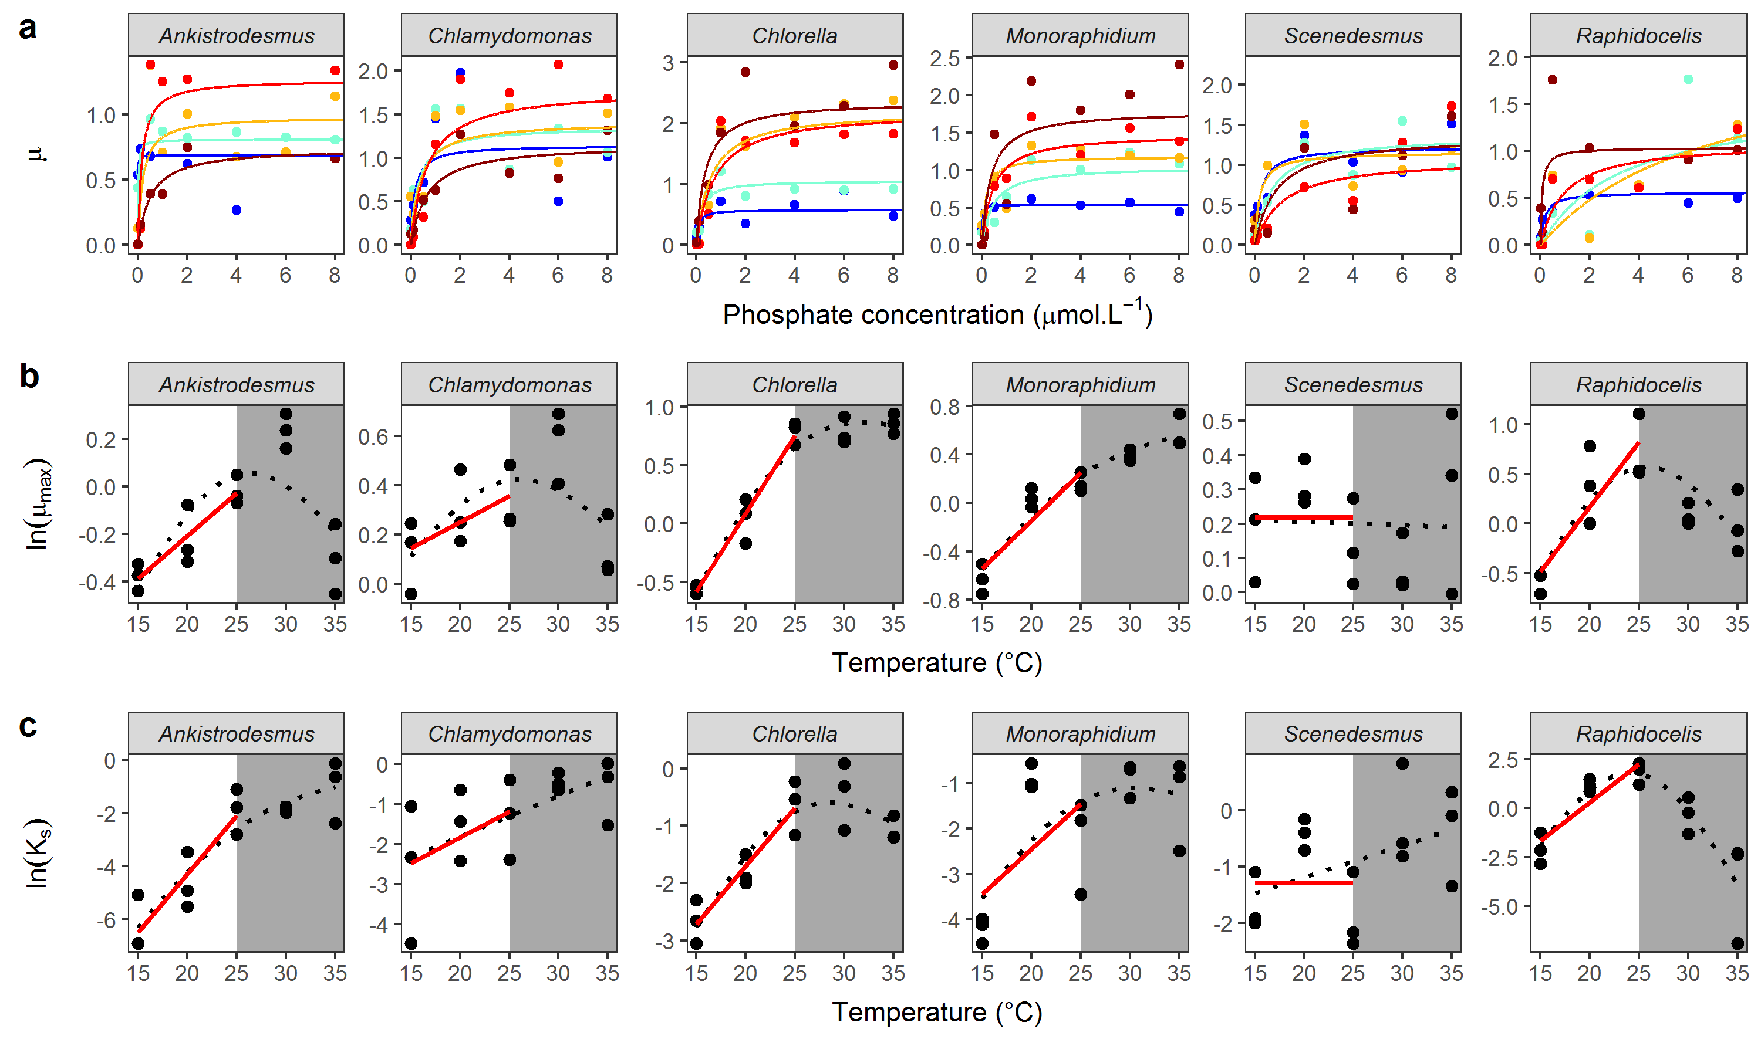

## **Figure 1**. Interspecific variation in metabolic traits. (a) Monod curves for each species, with growth rate *μ* as a function of phosphate concentration (μmol·L-1) from 15°C (blue) to 35°C (dark red). Points represent the mean of the 3 replicates, and the Monod curve is drawn from the mean parameters across the 3 replicates. Note that the phosphate concentration levels in the experiment range from 0.01 to 50 μmol·L-1 but the x-axis was cut at 8 μmol·L-1 for clarity. (b) Maximum growth rate *µ*max as a function of temperature. (c) Temperature dependence of the half-saturation constant *KS*. Red lines represent the fit of the Boltzmann-Arrhenius within the operational temperature range (15 to 25°C, white area). Black dotted lines represent the fit of the GAM over the whole temperature range. See Tables S4A, S4B and S4C for more details about the temperature-dependence of *μ*max and *KS*.

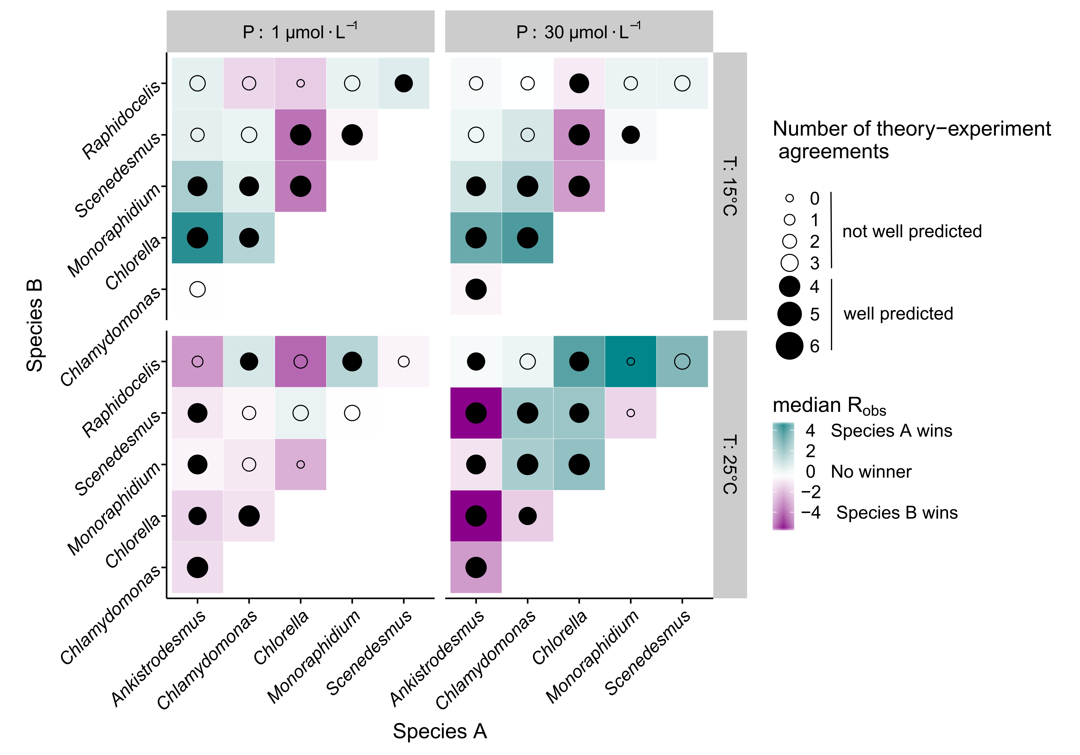

**Figure 2. Predicting competitive advantage from metabolic traits.** The colour indicates the identity of the competitively dominant species and strength of competitive advantage (median *R*obs over 6 replicates, see Fig S3B for *R*obs by replicate). The circle shows the agreement of the model predictions with the experimental outcomes (size: number of replicates correctly predicted out of 6, see Table 1).

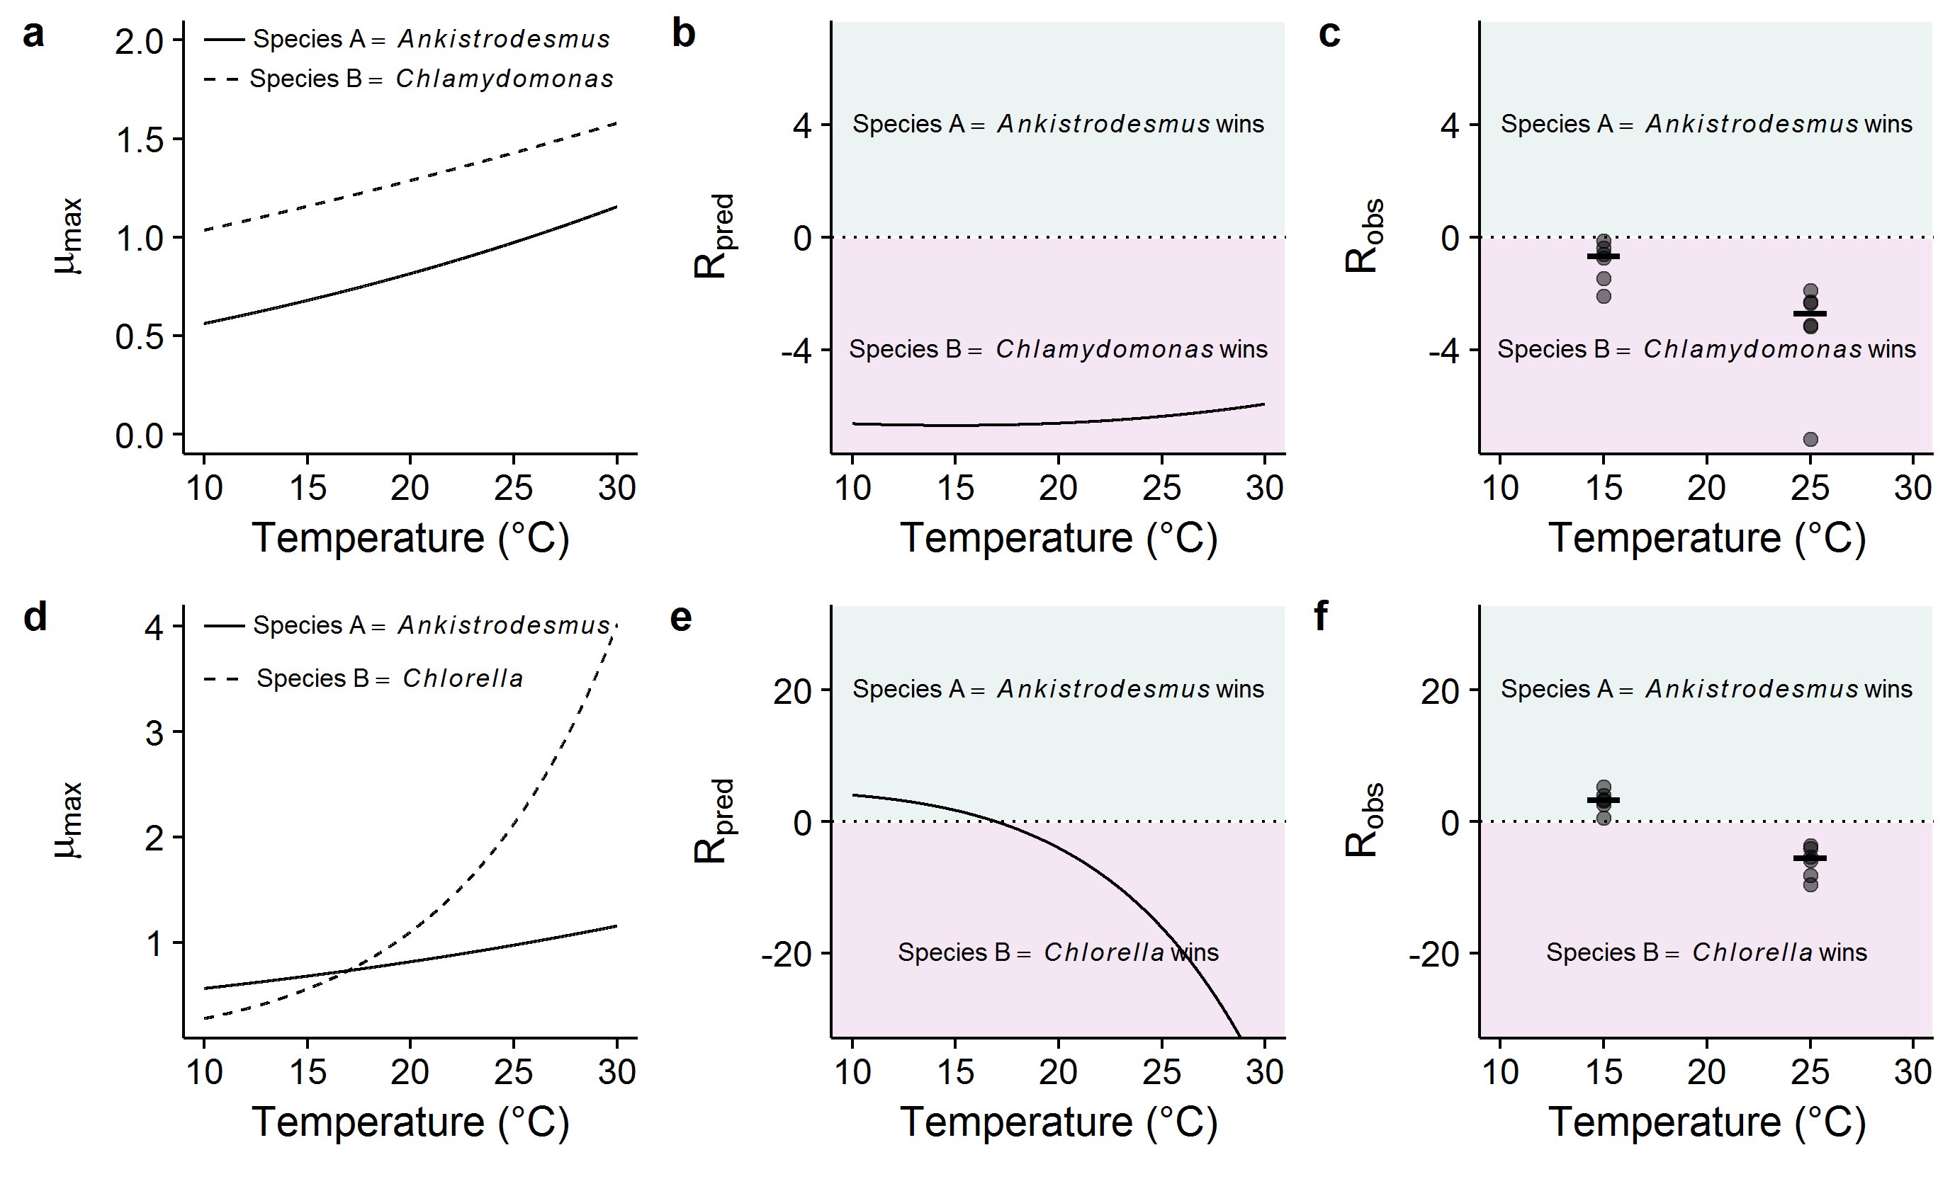

**Figure 3. Predicting reversals in competitive advantage from mismatches in metabolic traits.**  (a-c) competition between *Ankistrodesmus* and *Chlamydomonas*, (d-f) competition between *Ankistrodesmus* and *Chlorella*. (a & d) represent the temperature-dependence of *μ*max derived from the Boltzmann-Arrhenius models. In (a), *μ*max is always higher for *Chlamydomonas*, while in (d), *Ankistrodesmus* has a higher *μ*max at low temperatures, but a lower *μ*max at high temperatures. This translates into different shapes of predicted *R***∞** with temperature, with a reversal of competitive advantage with temperature in the *Ankistrodesmus*-*Chlorella* competition (e) while there is no reversal in the *Ankistrodesmus-Chlamydomonas* competition (b). These theoretical predictions are in line with the experimental observations (c, f; N = 6 replicates per temperature plus medians as segments).

# Tables

**Table 1**. **Proportion of competitive advantages correctly predicted by theory.** Results are shown for the full dataset (including competitions at both temperatures and nutrient concentrations), by temperature, nutrient concentration, and species (where only competitions involving each individual species are considered in turn). The column “*R*∞” uses equation 6, and assumes nutrient saturated conditions, while “*R*” corresponds to equation 5, and explicitly captures nutrient limitation. “*N*” indicates the number of competitions in each subset. *P* values indicated in parentheses were obtained by bootstrapping (see Section S5 in SI). The experimental competition data uses the LDA discrimination method. Analogous results for the random forest and rpart discrimination methods are shown in Tables S6A and S6B.

|  | ***R*∞** |  | ***R*** |  | ***N*** |
| --- | --- | --- | --- | --- | --- |
| *Full dataset* | | | | | |
|  | 0.67 | (0.006) | 0.67 | (0.005) | 342 |
| *By temperature* | | | | | |
| °C | 0.73 | (0.034) | 0.70 | (0.041) | 171 |
| °C | 0.61 | (0.139) | 0.64 | (0.070) | 171 |
| *By nutrient* | | | | | |
| [P] = 1 µmol·L-1 | 0.65 | (0.020) | 0.62 | (0.044) | 170 |
| [P] = 30 µmol·L-1 | 0.69 | (0.012) | 0.72 | (0.005) | 172 |
| *By species* | | | | | |
| *Ankistrodesmus* | 0.78 | (0.005) | 0.75 | (0.008) | 116 |
| *Chlamydomonas* | 0.69 | (0.025) | 0.71 | (0.012) | 117 |
| *Chlorella* | 0.82 | (0.007) | 0.80 | (0.012) | 115 |
| *Monoraphidium* | 0.63 | (0.073) | 0.68 | (0.028) | 115 |
| *Scenedesmus* | 0.63 | (0.050) | 0.61 | (0.077) | 115 |
| *Raphidocelis* | 0.45 | (0.771) | 0.45 | (0.751) | 106 |

**Table 2.** **Number of observed and predicted reversals in competitive advantage between pair of species.** Observed reversals are qualified when the median *R* of a pair of species across 6 replicates changes sign with temperature. They are compared to reversals predicted by the model.

|  | ***Observed revs.*** | | ***Predicted revs. (R∞)*** | | ***Predicted revs. (R)*** | |
| --- | --- | --- | --- | --- | --- | --- |
|  | *Yes* | *No* | *N* | *Prop.* | *N* | *Prop.* |
| ***Full dataset*** | | | | | | |
|  | 18 | 12 | 11 | 0.61 | 10 | 0.56 |
| ***By nutrient*** | | | | | | |
| [P]=1 µmole·L-1 | 10 | 5 | 6 | 0.60 | 4 | 0.40 |
| [P]=30 µmole·L-1 | 8 | 7 | 5 | 0.62 | 6 | 0.75 |
| ***By species*** | | | | | | |
| *Ankistrodesmus* | 7 | 3 | 5 | 0.71 | 4 | 0.57 |
| *Chlamydomonas* | 6 | 4 | 2 | 0.33 | 2 | 0.33 |
| *Chlorella* | 8 | 2 | 7 | 0.88 | 8 | 1.00 |
| *Monoraphidium* | 4 | 6 | 3 | 0.75 | 3 | 0.75 |
| *Scenedesmus* | 6 | 4 | 3 | 0.50 | 2 | 0.33 |
| *Raphidocelis* | 5 | 5 | 2 | 0.40 | 1 | 0.20 |